

Technical Note:

Retrieve Photo Data from Instagram Using Instagram API

NIH Proposal for Food Environment

Project conducted by:

San Diego State University

5500 Campanile Drive

San Diego, CA 92182-4493

Report prepared by:

Yi-ting Chuang

Elias Issa

Jay Yang

**Department of Geography, San Diego State University**

Nov. 2015

# *Abstract*

This technical note introduces how to retrieve **food photos at Downtown** **San Diego** from Instagram by using Instagram API. This notes searched photos by setting location ids, based on longitude and latitude, and radius arguments.

# *Retrieve Food Photo at DOWNTOWN SAN DIEGO from Instagram Using Instagram API*

1. **What is Instagram?**

Instagram is an online mobile photo-sharing, video-sharing and social networking service that enables its users to take pictures and videos, and share them on a variety of social networking platforms, such as Facebook, Twitter, Tumblr and Flickr. A distinctive feature is that it confines photos to a square shape, similar to Kodak Instamatic and Polaroid images, in contrast to the 4:3 aspect ratio typically used by mobile device cameras. Users can also apply digital filters to their images. (<http://en.wikipedia.org/wiki/Instagram>)

1. **What is Instagram API?**

Registered users can search photos and related information according to different arguments by using Instagram API.

1. **Does the API need a key?**

Yes, before utilizing Instagram API, developers need to get an access key for calling methods of Instagram API.

1. **How to get an authentification?**

The Instagram API uses the OAuth 2.0 protocol to get an authentication and authorization.

Some APIs only require the use of a client_id or authentification.

The authentification requests require an access_token. In order to receive an access token, follow the instructions:

* Go to the following URL:

<https://instagram.com/accounts/login/?next=%2Fdeveloper%2Fauthentication%2F>

* The user will be asked to log in.
* The server will redirect the user in one of two ways that you choose: **Server-side flow (recommended) or Implicit flow**
* Using the Server-Side flow method, go to the following URL

<https://api.instagram.com/oauth/authorize/?client_id=CLIENT-ID&redirect_uri=REDIRECT-URI&response_type=code>

* During this step, the user will be provided with a login screen then a confirmation screen to allow the access to Instagram data.
* Once it is working, the user will receive a code parameter from Instagram (redirect)

<http://your-redirect-uri?code=CODE>

The last step is to exchange this code with the access token. These are the required parameters:

1. **client_id**: your client id
2. **client_secret**: your client secret
3. **grant_type**: **authorization_code** is currently the only supported value
4. **redirect_uri**: the redirect_uri you used in the authorization request. Note: this has to be the same value as in the authorization request.
5. **code**: the exact code you received during the authorization step.

* For more information, go here: <http://instagram.com/developer/authentication/>.

1. **What can you do with the Instagram API?**

* 8 ways to use Instagram API:

1. Search Tags

2. Incorporate Photos on Websites

3. View Photos from Specific Locations in Real Time

4. View Popular and Trending Photos

5. Print Photos from Events and Tags Instantly

6. Make Custom Items

7. Market Venues, Events and Businesses

8. Create Event Live Feeds

For more details on each way, please visit this website:

<http://mashable.com/2013/09/19/instagram-api-uses/#hP5TLvTzWmqj>

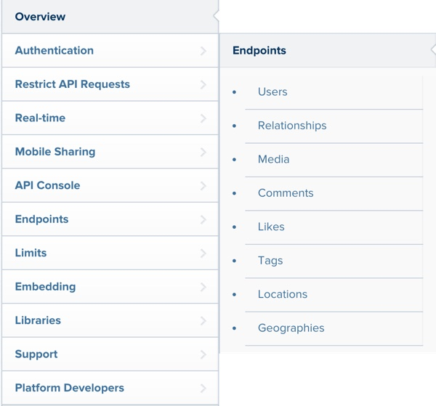

* Instagram's endpoints represent a variety of REST-based web service URLs for accessing much of Instagram's overall functionality:

1. The User endpoints allow you search for users by name, look up basic information about them, and see the media in their newsfeed (people they follow on Instagram) as well as their own media posts and liked media.

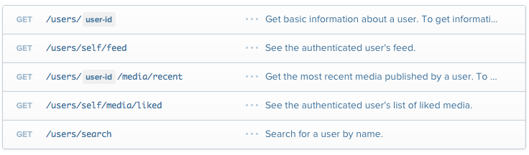

To get the parameter details about each of the users endpoints, visit this website: <https://instagram.com/developer/endpoints/users/>

1. The Relationships endpoint allows you to retrieve follower lists (both who a user follows and who they're followed by) as well as respond to relationship requests and make changes to relationships.

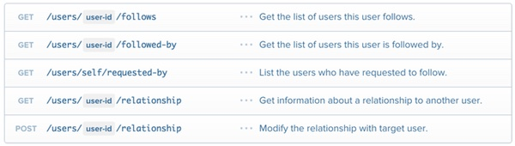

1. With the Media endpoint, you can retrieve information about an Instagram photo or video. It also provides geo-search capabilities to find media posted from a specific time and place.

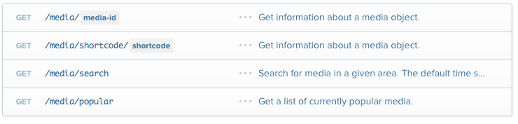

1. As expected, the Comments, Likes and Tags endpoints let you enumerate comments, likes and tags for media items as well as applying (or not applying) these to media.

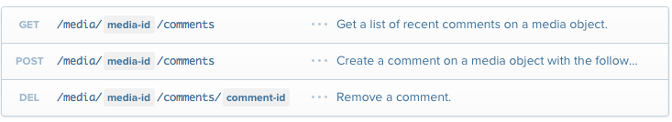

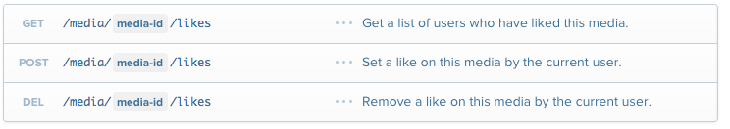

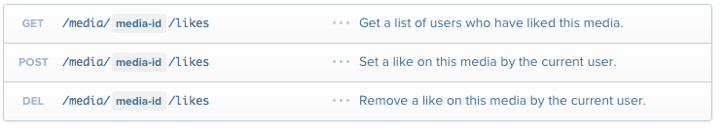

1. Social service APIs such as Twitter and Instagram have their own Place databases. Instagram calls these Locations. The Location endpoints allow you to look up location IDs in the Instagram service by GPS coordinate and find media posted from those location IDs. Here's an example query for known locations (or places) near the Eiffel Tower's GPS coordinates

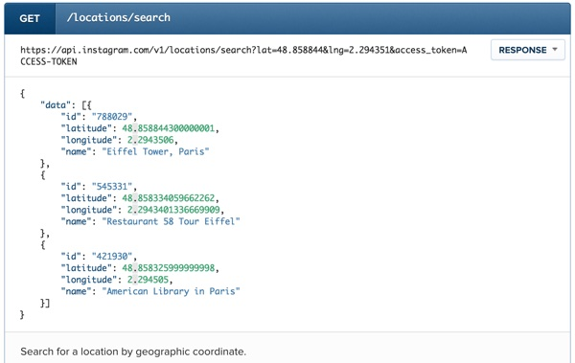

Instagram returns its native location IDs for known places nearby. For example, you could use this with other location queries to find media posts from Restaurant 58 Tour Eiffel.

1. **How to find photos for specific geographic areas? (e.g. Downtown San Diego)**

Go to “Location Endpoints” on Instagram website: <http://instagram.com/developer/endpoints/locations/>.

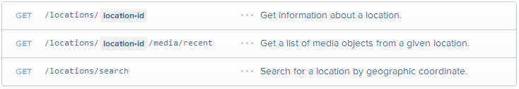

1. The third method can get a list of Instagram’s location ids by setting:

**Lng:** A valid longitude, in decimal format, for doing radial geo queries. **(e.g. -117.161)**

**Lat:** A valid latitude, in decimal format, for doing radial geo queries. **(e.g. 32.726)**

**Distance:** A valid radius used for geo queries, greater than zero and less than 5000m, for use with point-based geo queries. The default value is 1000m.

Note: Instagram API can only respond 20 location ids at a time. For getting more ids at a time, please utilize Facebook’s Graph API to get Facebook’s location ids and convert them into Instagram’s location ids.

1. The second method can search photos based on:

**Location_id:** Instagram location ids, which can be generated by using the third method.

**Other parameters:** <http://instagram.com/developer/endpoints/locations/>

1. **The following is an example of photos with “food” tag at Downtown San Diego (latitude: 32.715754; longitude: -117.161093) with 5 kilometers radius.**

**Instagram Location IDs:**

"data":[{"latitude":32.726005369,"id":"76449888","longitude":-117.16114532,"name":"Areta Crowell Center"},{"latitude":32.725929,"id":"252182784","longitude":-117.160861,"name":"Sharp Rees-Stealy Medical Centers"},{"latitude":32.726120597,"id":"254994208","longitude":-117.161077997,"name":"Mission Bay Park"},{"latitude":32.725788399,"id":"14535462","longitude":-117.160915565,"name":"Hawthorn and 4th"},{"latitude":32.726098621,"id":"451226492","longitude":-117.161246422,"name":"Sharp Rees Steely"},{"latitude":32.725939694,"id":"394497","longitude":-117.161286506,"name":"Sharp Rees-Stealy Downtown San Diego"},{"latitude":32.725735958,"id":"389099054","longitude":-117.161148371,"name":"Siti Medical Spa"},{"latitude":32.72626119,"id":"5824990","longitude":-117.16079247,"name":"Sharp Rees-Steely Urgent Care"},{"latitude":32.725645,"id":"14251612","longitude":-117.160856,

**Photo data:**

"data":[{"attribution":null,"tags":[],"type":"image","location":{"latitude":32.726120597,"name":"Mission Bay Park","longitude":-117.161077997,"id":254994208},"comments":{"count":7,"data":[{"created_time":"1416796151","text":"\u270c\ufe0f\ud83d\ude4c\ud83d\udcaa\ud83d\udd1d","from":{"username":"nnectoux","profile_picture":"https:\/\/igcdn-photos-b-a.akamaihd.net\/hphotos-ak-xpa1\/t51.2885-19\/10632376_630528803732193_1124873594_a.jpg","id":"34891169","full_name":"Nelson Nectoux"},"id":"860470941825098012"},{"created_time":"1416805872","text":"\ud83d\udc4f\ud83d\udc4f\ud83d\udc4f","from":{"username":"fsabbatini","profile_picture":"https:\/\/igcdn-photos-e-a.akamaihd.net\/hphotos-ak-xpf1\/t51.2885-19\/10693517_730206550394612_1811208857_a.jpg","id":"22278664","full_name":"Freddy Sabbatini"},"id":"860552490226540560"},{"created_time":"1416807791","text":"@nnectoux amazinggg!! Foi demais hoje, energia mega positiva!","from":{"username":"carlamariazinha","profile_picture":"https:\/\/igcdn-photos-c-a.akamaihd.net\/hphotos-ak-xpa1\/t51.2885-19\/10729199_1493937554215498_1974034382_a.jpg","id":"30615503","full_name":"Carla Maria"},"id":"860568590456709165"},{"created_time":"1416807824","text":"@fsabbatini at\u00e9 muito breve, sofri mas foi demais!!",

**Final outputs:**

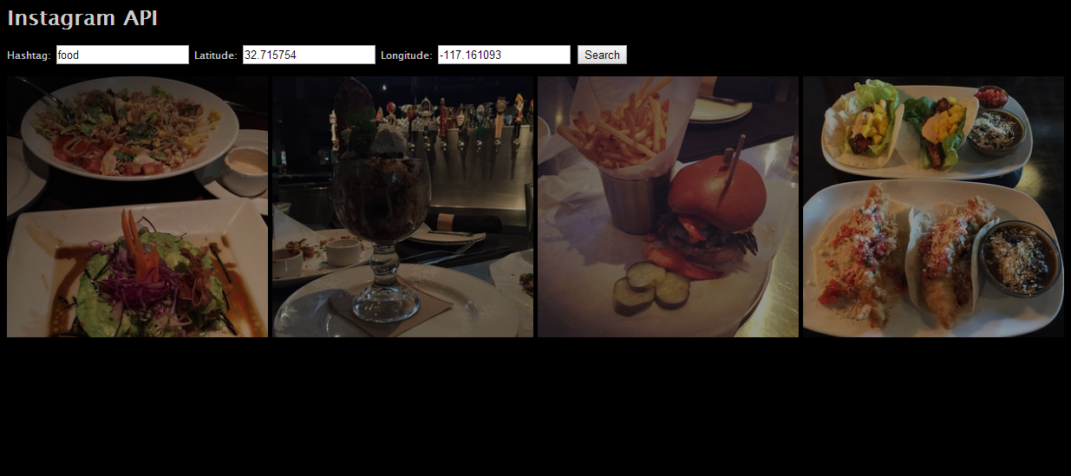

1. **What Platforms does the Instagram API support?**

You can access the Instagram API with any platform using its REST endpoints. Instagram provides libraries for Python and Ruby. Packagist offers a number of community libraries of Instagram for PHP (<https://packagist.org/search/?tags=instagram>).

1. **Limitations**

A limitation of using Istagram API to search location ids is that it only responds 20 location ids at a time. If you want to get more location ids at once, you can utilize Graph API by Facebook to get a list of facebook_places_ids (500 data) and convert it into Instagram location ids by using “locations/search?facebook_places_id” method. You can get 500 Instagram location ids instead of 20.